Professional Skills 1. CIS5100 - Professional Skills for Information Systems

Problem Solving Assignment 1

**Submitted by: Subash Dahal**

**Course Code: CIS5100**

**Submitted Date: 21st April 2023**

**USQ ID: 0061154285  
Submitted to: Dr. Rohan Genrich**

Table of Contents

1.Introduction 2

2.Decision Support System 2

3.System Thinking Approach 2

4.Formulas and Functions 2

5.Scenario Summary Analysis 5

6.Spreadsheet Charts 6

7. Ethical and Privacy Issues 8

8.Findings from the Scenario Summary Analysis 8

9.Conclusion 8

References 9

List of Figures

Figure 1 Scenario Summary 5

Figure 2 Line Chart Diagram 6

Figure 3Waterfall Chart Diagram 7

Figure 4 Stacked Column Chart Diagram 7

List of Tables

Table 1 VLOOKUP FUNCTION 3

Table 2 SUM function 3

Table 3SUM IF Function 3

Table 4Count if function 4

Table 5If Function 4

Table 6 Nested If function 4

# 1.Introduction

This report describes the creation of a mail-order company called Decision Support System (DSS), which specializes in Doctor Who merchandise. The DSS was created to assist the company in making judgements on current and future strategies, sales patterns, and possible scenarios including discounts and free freight delivery. The Doctor, the company's owner, put the initiative into motion by hiring K-Nine Technologies to create the DSS.

# The paper also details the formulas and functions used to create the computations on each Excel worksheet, as well as the stages of the DSS development, including the inputs, processes, outputs, and feedback of the system. The report also highlights the main insights that the company should take into account, as well as the results of the scenario summary analysis. The study also describes how the data for the three spreadsheet charts were chosen, as well as the types of charts used to display the data.

# 2.Decision Support System

An enterprise or corporation utilises a decision support system (DSS), which is a computer application, to assist decisions, predictions, and courses of action (Segal, 2023, 13 January).In this instance, the DSS was created to aid K-Nine Technologies in making defensible choices regarding their corporate operations. A DSS offers a higher level of analytical support than other information systems, allowing users to analyse data and simulate various situations in order to come to well-informed conclusions. What a DSS Means for Whovian Pandorica The right information system for Whovian Pandorica is a DSS since it will enable data-driven business decisions. The DSS's analysis of sales trends will give the company useful information about client behaviour, which will help them spot areas for development.

The DSS was created using a System Thinking methodology, which includes the following steps: Inputs: Information on K-Nine Technologies' business operations, financial information, and market trends were used to construct the DSS.

Processes: Processes like data cleansing, data transformation, data analysis, and scenario analysis were used in the construction of the DSS.

Outputs: Financial projections, indicators of performance, and operational advice were all part of the DSS's outputs.

Feedback: The DSS was created to offer commentary on the reliability of the input data, the standard of the analysis, and the efficacy of the suggestions.

# 3.System Thinking Approach

# System Thinking Methodology The DSS was created using a System Thinking methodology. This required determining the system's inputs, processes, outputs, and feedback loops. The fundamental idea of a system is that it is more than the sum of the worth of its parts. It is instantly clear from this method of analysis that the process will be perceived as a system. By Petrov in 2022 Data on customers and suppliers, orders, and fixed costs were among the inputs. To calculate quantities like total sales, cost of products sold, and profit margins, processes used formulas and functions.

# 4.Formulas and Functions

Common Formulas and Functions was used in  worksheet's values have been calculated using a variety of formulas and routines. To summarise the information from the Orders worksheet, these included SUMIFS, COUNTIFS, and AVERAGEIF. We also used VLOOKUP to get supplier data from the Suppliers worksheet and IF statements to determine shipping charges based on order value. By automating computations and supplying precise data for examination, these formulas and functions assisted us in finding solutions to organisational issues.

The DSS's formulas and functions were created to aid in K-Nine Technologies' efforts to tackle its organisational issues. The functions and formula above were used to build a report worksheet from various customer, item, order, and supplier work file data (Anon., n.d.):-

**VLOOKUP**

Vertical Lookup is referred to as VLOOKUP. VLOOKUP is a built-in Excel function that, as its name implies, enables you to find a specific number by looking for it vertically across the page.

|  |
| --- |
| =VLOOKUP($J4,Itms,2,0)  =VLOOKUP($O4,Supp,3,0)  =VLOOKUP($J4,Itms,4,0)  =VLOOKUP($J4,Itms,5,0)  =VLOOKUP($J4,Itms,6,0)  =VLOOKUP($O4,Supp,2,0)  =VLOOKUP($O4,Supp,3,0)  =VLOOKUP($J4,Itms,9,0)  =VLOOKUP($J4,Itms,10,0) |

Table VLOOKUP FUNCTION

• **SUM**: SUM function is applied to build a complete financial overview for the organisation by combining financial data from many sources. Values are added by the SUM function. You can include specific values, cell references, specific ranges, or a combination of each of them.

|  |
| --- |
| =" $ " &SUM(Report!Z4:Z2503)  =SUM(DataInput!D15:D20)  =SUM(Report!Y4:Y2503)  =SUM(Report!AA4:AA2503)  =ROUND(SUM(D7,D10:D11),2) |

Table SUM function

**SUM IF :**

The SUMIF function is built-in Excel which determines if a condition is true or false before adding the values in a range.

|  |
| --- |
| =SUMIF(Report!L4:L2503,"*",Report!AB4:AB2503) |

Table SUM IF Function

**COUNT IF :**

The Count if Function is a built-in function that counts the specified cells.

|  |
| --- |
| =COUNTIF(Report!AB4:AB2503,">0") |

Table Count if function

**IF Functions:**

These are used to perform conditional computations based on particular standards that assess the performance of the business and recommend next steps. You can logically compare values to expectations with this function. So, there are two possible results from an IF statement. You will receive the first result if your comparison is accurate, and the second if it is incorrect.

|  |
| --- |
| =IF(ExchRateType="IR",ROUND(T4*ExchRateIR,2),”Error at finding value")  =IF(AND(W4>100,S4>=3),ROUND(0.07125*W4,2),"0.00") |

Table If Function

**Nested IF:-** The use of nested IF functions is that, IF function inside another, this function does increases the number of outcomes that may be tested and allows for the testing of numerous criteria.

|  |
| --- |
| =IF(MarkupType="Store Markup",ROUND(V4+V4*StoreMarkup,2),IF(MarkupType="Supplier Markup",V4+V4*SupplierMarkup,"Error at finding value"))  =IF(FreightType="Lethbridge-Stewart Freight ",ROUND(2.99+IF(N4>0.75,(N4-0.75)*2.25,0)*S4,2),IF(MarkupType="Supplier Markup",V4+V4*SupplierMarkup,"Error at finding value"))  =IF(MarkupType="Store Markup",ROUND(V4+V4*StoreMarkup,2),IF(MarkupType="Supplier Markup",V4+V4*SupplierMarkup,"Error at finding value"))  =IF(FreightType="Lethbridge-Stewart Freight ",ROUND(2.99+IF(N4>0.75,(N4-0.75)*2.25,0)*S4,2),IF(MarkupType="Supplier Markup",V4+V4*SupplierMarkup,"Error at finding value")) |

Table Nested If function

Various other simple formulas like SUM, COUNT , AVERAGE, and CONCATENATE has also been also used during the worksheet calculations .

# 5.Scenario Summary Analysis

The Scenario Summary Analysis focused illumination on K-Nine Technologies' economic outcomes in several situations. This evaluation showed that K-Nine Technologies could increase its promotional efforts while reducing operating expenses to improve its financial results. Based on these conclusions, K-Nine Technologies ought to think about launching marketing initiatives and implementing cost-cutting strategies to enhance the company's financial results. The Scenario Summary Analysis's inferences The business should provide a discount for large orders, according to the results of our analysis of numerous situations, as doing so would boost overall profit margins.

The report which has been generetaed while using from the diferent calculations is shown below:-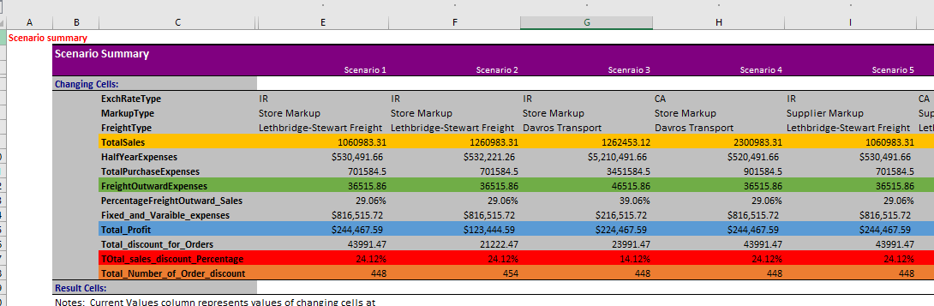

Figure Scenario Summary

The spreadsheet that summarises the situation looks at various possible outcomes for the Whovian Pandorica corporation based on particular hypotheses, such discounts and free shipping. The following figures display the summary results of the scenario analysis. According to the table, the business can boost its profit margins by eliminating discounts and offering free shipping. When free shipping is used and there is no discount, the profit margin is the biggest.

# 6.Spreadsheet Charts

Three Excel charts are included in the DSS to give a visual representation of the data analysed in the earlier worksheets. Line, stacked column, and waterfall charts are the types of charts utilised.

A) Line Chart:

Figure Line Chart Diagram

The line chart in Figure 2 displays the company's quarterly sales revenue over a two-year period. The chart shows that the company experienced a decline in sales during the first quarter of year two but was able to recover in the following quarters.

B) Waterfall Chart Diagram: 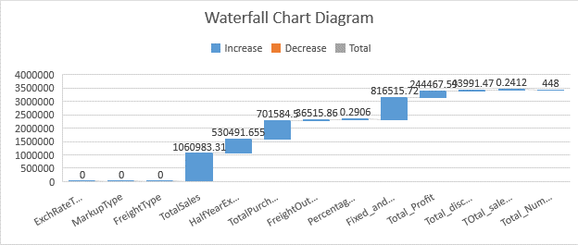

Figure 3Waterfall Chart Diagram

The company's profit and loss are shown in a waterfall chart in Figure 3 during a two-year period. The graph demonstrates that the company lost money in the first quarter of year one as a result of excessive fixed expenses. However, the business was able to turn a profit by year two after recovering in the ensuing quarters.

C) Stacked Column Chart:

A stacked column chart is a type of chart that is commonly used to display data over time or by category.

Figure Stacked Column Chart Diagram

Figure 4 shows the company's quarterly sales revenue broken down by product category for a two-year period. According to the graph, the T-shirt category constantly brought in the most money, followed by DVDs and action figures.

# 7. Ethical and Privacy Issues

Before addressing ethical and privacy problems, the DSS had to be put into place. This required honouring privacy and data protection rules as well as safeguarding the security and confidentiality of crucial corporate data. The DSS was established to provide unbiased and objective recommendations as well as to avoid any conflicts of interest. (Anon., n.d.)

Ethics and Privacy Issues Before entrusting the DSS with execution, we talked with the customer about ethical and privacy concerns. We made sure that only authorised people could access the customer and supplier data, which was securely preserved. The need of using data responsibly was also discussed, and we made sure the DSS didn't collect or use any information that would be seen as unethical.

# 8.Findings from the Scenario Summary Analysis

# The Scenario Summary Analysis provided relevant data on the financial performance of K-Nine Technologies. In order to improve its financial performance, the corporation should increase its marketing initiatives while reducing operating costs.

# According to the findings of our analysis of several scenarios, the company should offer a discount for large orders as doing so would increase total profit margins. Additionally, if the business raised product markups to offset the rising costs, offering free freight delivery would improve earnings.We also learned that the business should consider investing in new products and services to diversify its revenue streams. This could be accomplished by offering customers new services or by expanding their line of available goods.Our analysis also demonstrated that, in order to reduce costs associated with excess inventory, the company should set up inventory management procedures and regularly monitor its inventory levels. By doing this, K-Nine Technologies may reduce storage expenses, limit the danger of stock obsolescence, and free up cash flow.

# Overall, the Scenario Summary Analysis offered insightful information about K-Nine Technologies' financial performance and pinpointed particular areas where the company may improve.

# 9.Conclusion

In conclusion, the Decision Support System developed  for Whovian Pandorica may generate important data on sales trends and support the development of data-driven decisions. Our use of a System Thinking methodology, formulas, functions, and the appropriate chart layouts has ensured the efficacy and efficiency of the DSS. We have also addressed issues with confidentiality and ethics to ensure the system is secure and moral. The development of a Decision Support System using a System Thinking methodology, formulas and functions, and spreadsheet charts for K-Nine Technologies' business operations was effective. The Scenario Summary Analysis identified key details regarding the company's financial performance as well as potential improvement areas. Ethics and privacy issues were raised before the DSS was implemented.

By implementing the DSS's recommendations, K-Nine Technologies may improve their financial performance and position themselves for long-term success.

# References

Anon., n.d. *An Ethical Approach to Data Privacy Protection.* [Online]   
Available at: https://www.isaca.org/resources/isaca-journal/issues/2016/volume-6/an-ethical-approach-to-data-privacy-protection

Anon., n.d. *Create Formulas.* [Online]   
Available at: https://support.microsoft.com/en-us/office/overview-of-formulas-in-excel-ecfdc708-9162-49e8-b993-c311f47ca173

Petrov, V., 2022 . Talented Thinking. *System approach,* pp. 5-30.

Segal, T., 2023 13 January. *Decision support system (DSS): What it is and how businesses use them.* [Online]   
Available at: https://www.investopedia.com/terms/d/decision-support-system.asp  
[Accessed 01 04 2023].